**PROTOCOL FOR THE USE OF THE POTENTIOSTAT**

***Version 1.0***

**Produced by: María Camila Guachetá Buendía**

# O**BJECTIVE**

Mostrar a la comunidad Uniandina el procedimiento que se debe seguir en el uso del potenciostato del laboratorio de sala limpia del departamento de ingeniería eléctrica y electrónica.

# SCOPE

Dar a conocer a la comunidad Uniandina el procedimiento a seguir para el uso del potenciostato, y que a través de esta herramienta se pueda facilitar la creación, implementación y validación de diferentes dispositivos.

# STEP BY STEP

## THIRD PART: POTENTIOSTAT

### CON**TE**XT

* The potentiostat or galvanostat is basically a signal generator and is widely used in electrochemistry. The potentiostat in the cleanroom laboratory only works in direct current, so the only tests that can be performed are to apply a voltage and measure a current or to apply a current and measure a voltage.
* The potentiostat has 5 electrodes and can work with up to 4 electrodes at the same time. The electrodes of the potentiostat are classified as follows:
* The 2 red electrodes are used to connect the working electrodes or electrodes of interest.
* The black electrode is used to connect the counter electrode. The counter electrode is used to measure the current that passes between the electrode(s) of interest and the counter electrode.
* The blue electrode is used to connect the reference electrode that is used to measure the voltage.
* The green electrode is the ground.

**▲** These electrodes usually have clamps attached to them that allow the electrodes on which all the tests will be performed to be held.

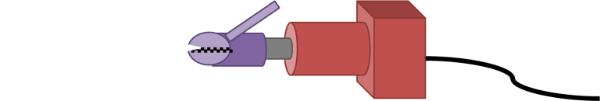

Figure 1: Electrode clamps.

Types of electrode arrangements:

|  |  |  |
| --- | --- | --- |
| **4-electrode arrangement** | **3-electrode arrangement** | **2-electrode arrangement** |
|  |  |  |

## METHOD FOR THE IMMOBILIZATION OF MOLECULES ON THE ELECTRODE SURFACE

### MATERIALS TO BE USED

* Potentiostat
* Rhodamine B (It is carcinogenic, so the use of gloves is recommended).

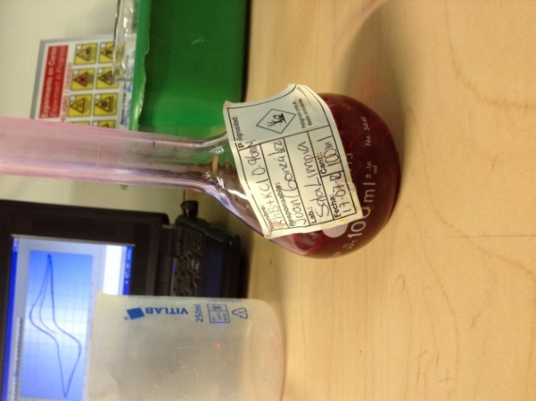

Figure 2: Rhodamine B.

* Copper and gold electrodes
* USB cable
* NOVA software
* Electrode cables and potentiostat clamps.

Note: Rhodamine can only be immobilized on copper.

### PROCEDURE

1. Place the rhodamine in a beaker.
2. Make a 2-electrode arrangement.
3. Place the copper and gold electrodes in the potentiostat electrode clamps. The copper electrode will be connected to the red electrode and the gold electrode to the black electrode.

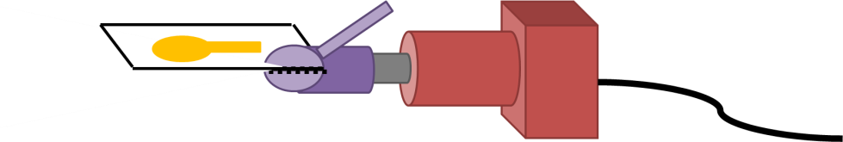

Electrode on which the experiment will be performed.

Figure 3: Electrode on which the experiment will be performed held with the potentiostat electrode clamps.

In this procedure, a voltage will be applied, and the current generated during an interval of 1 or 2 minutes at 1V will be measured.

1. Open the NOVA software.

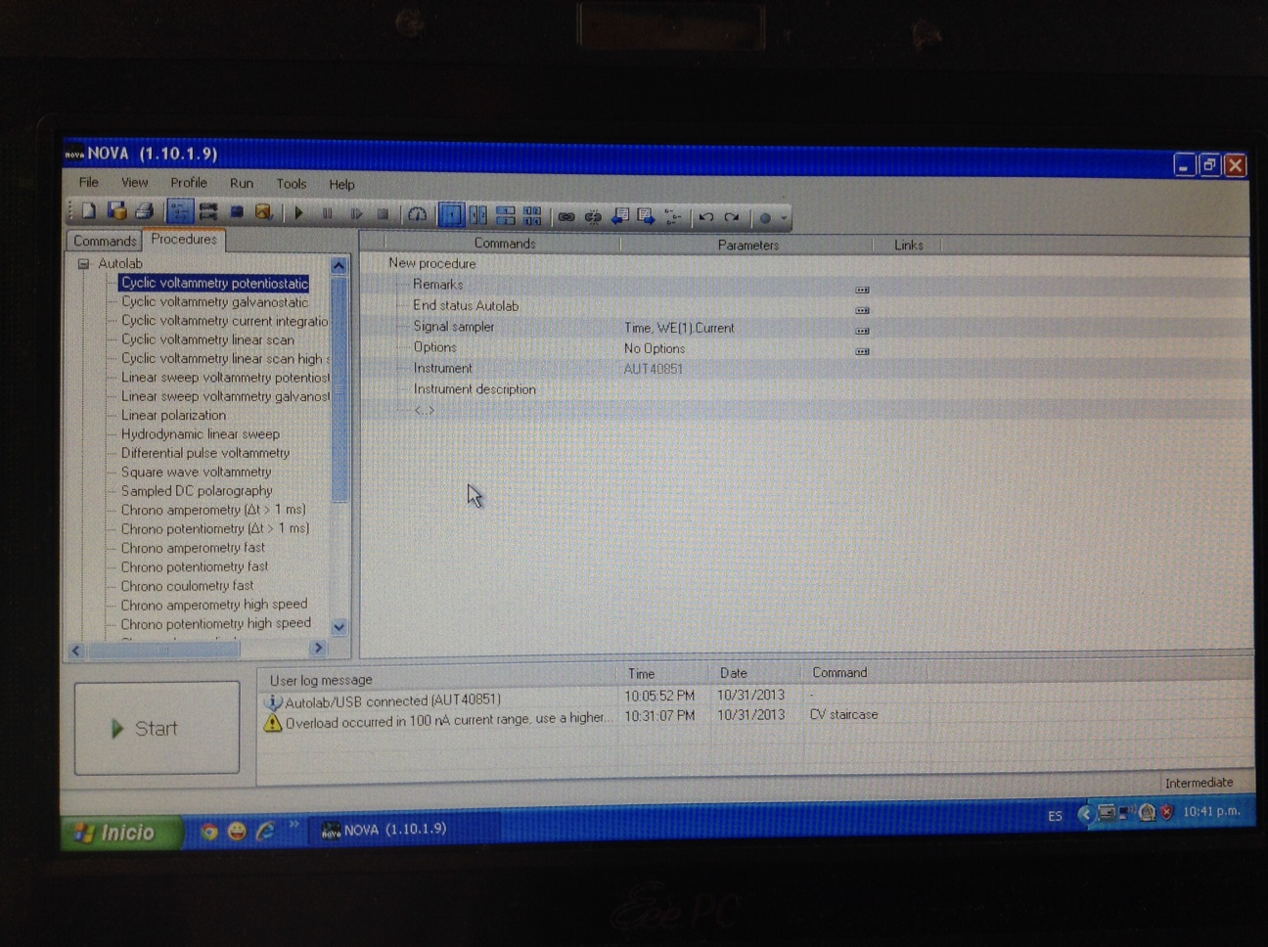

Figure 4: Window that appears when opening the NOVA software.

1. Select the technique to be used. For this procedure, the chrono potentiometry technique is used.



Figure 5: Selection of the Chrono potentiometry technique.

1. The following information will appear, where the Wait time that is by default set to 5s should be changed to 120s, and the applied potential should be changed to 1V.

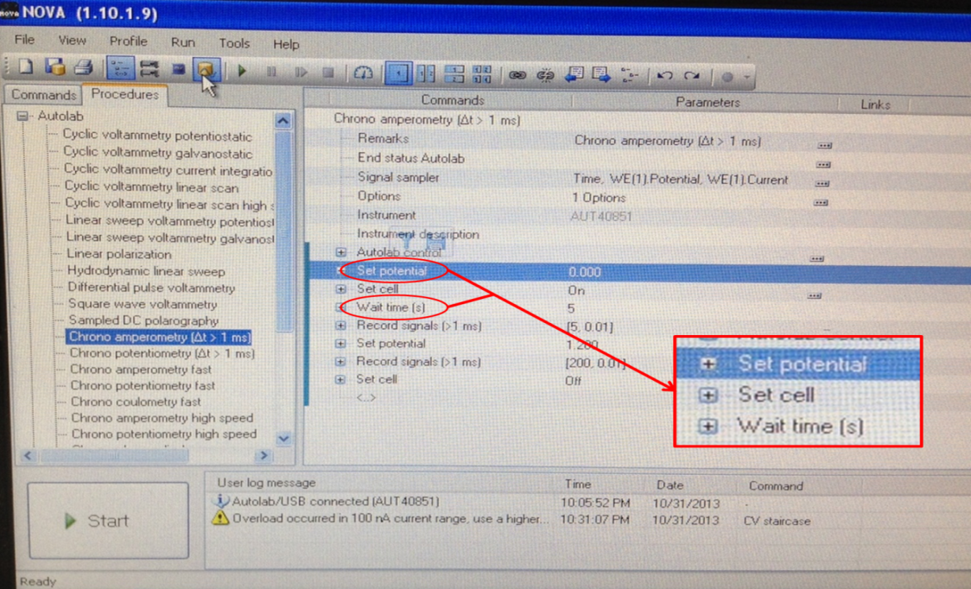

Figure 6: Parameters to change in the Chrono potentiometry technique.

1. What is done now is to place the electrodes inside the Rhodamine B and keep them as still and as close to each other as possible, and then click "Run" in the NOVA software.



Figure 7: Electrodes together and start.

1. What remains now is to wait for 2 minutes until the simulation is finished and keep the electrodes as still as possible.

While the simulation is running, the results can be seen:

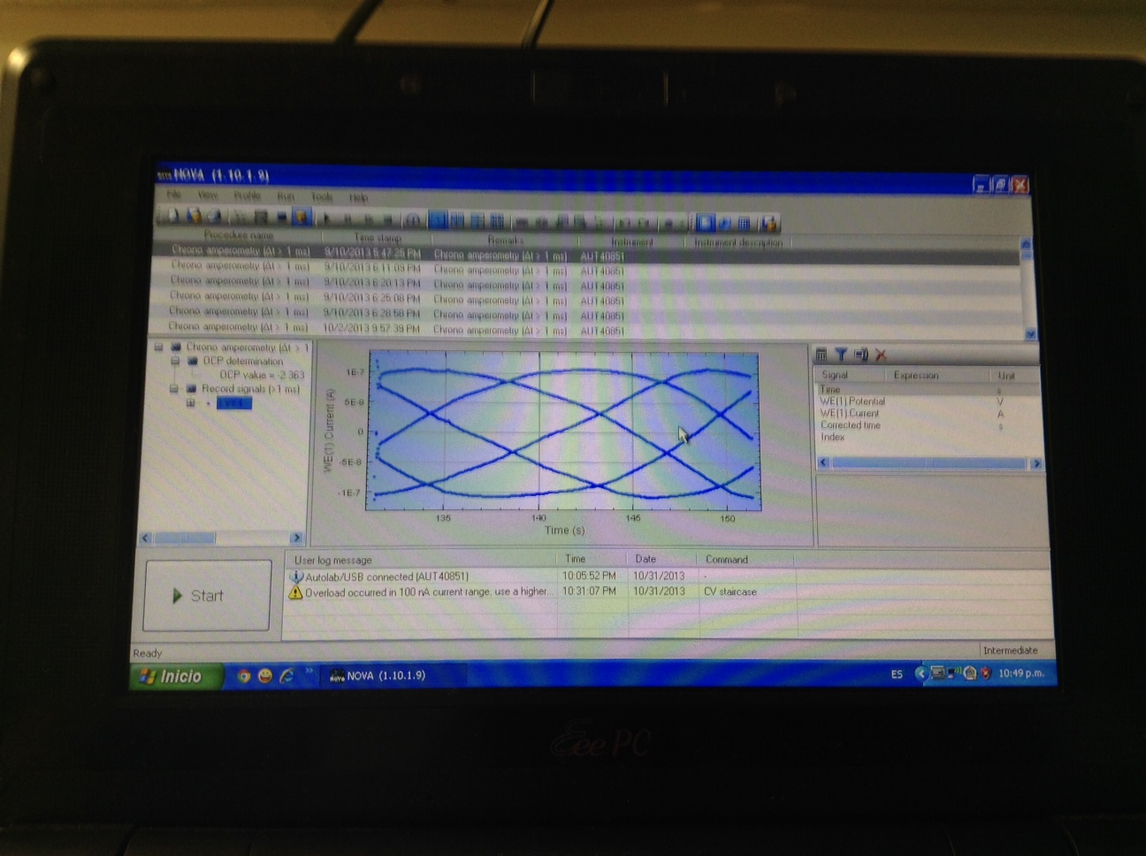

Figure 8: Result due to electromagnetic noise.

In the previous image, the expected simulation results are not shown because they are affected by electromagnetic noise. Since the signals to be measured are very weak, this noise prevents the results from being visible. Therefore, it is recommended to use a Faraday cage to eliminate this noise and observe the results clearly. However, this noise does not affect the immobilization of Rhodamine B.

When the program finishes simulating, the electrodes can be removed from the Rhodamine B and carefully cleaned of excess Rhodamine B using paper. After this, the following results are obtained:



Figure 9: Copper (left) and gold (right) electrodes.

As can be seen in image 12, the immobilization of Rhodamine B was achieved only on the copper electrode.

## METHOD FOR CLEANING AN ELECTRODE SURFACE

### MATERIALS TO BE USED

* Potentiostat.
* Diluted Sulfuric Acid (widely used for cleaning gold electrodes).

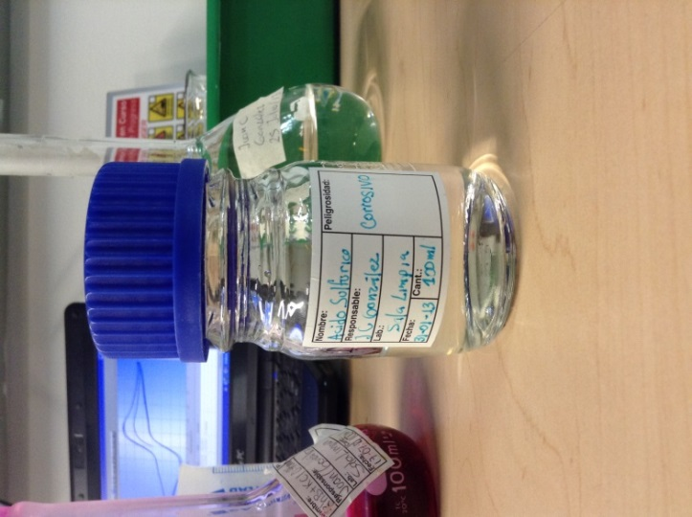

Figure 10: Sulfuric acid.

* Copper and gold electrodes to be cleaned.
* USB cable.
* NOVA software.
* Electrode cables and potentiostat clamps..

### PROCEDURE

1. Diluted sulfuric acid is placed in a beaker.
2. The gold and copper electrodes are connected to the electrode clamps of the potentiostat. **▲**
3. The potentiostatic cyclic voltammetry technique of the NOVA software will be used. In the right column of the NOVA software window, all the techniques that the software has can be seen. In that column, you should look for the option: Cyclic Voltammetry Potentiostatic and double-click on it. **▲**

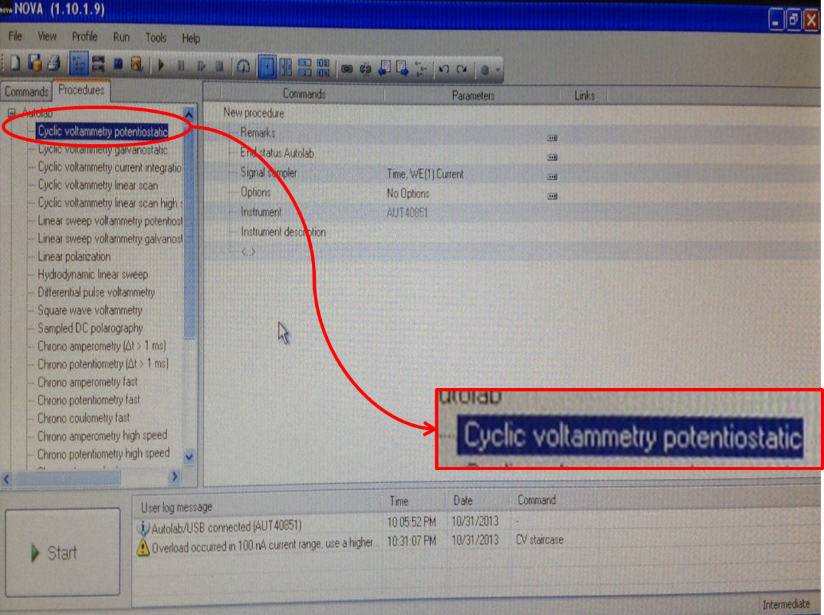

Figure 11: Cyclic voltammetry in the NOVA software.

1. The following information will appear in the NOVA window. Select the CV staircase option*.* **▲**

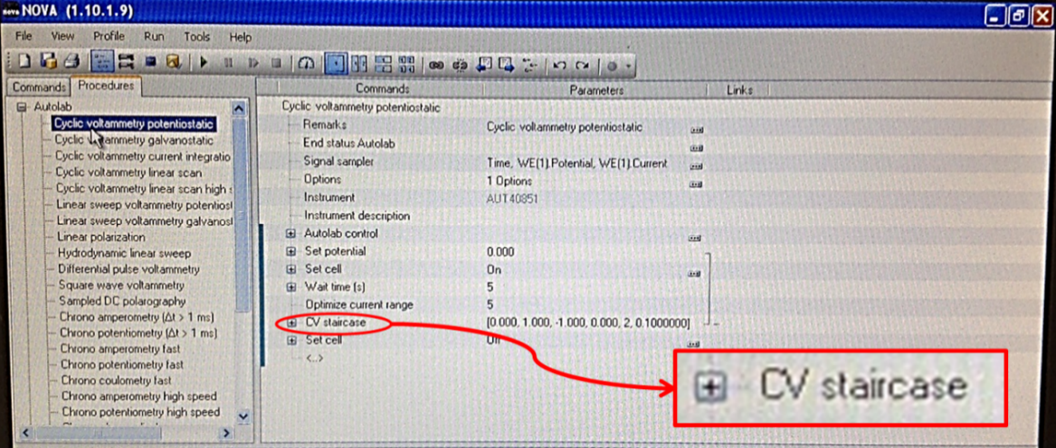

Figure 12: CV staircase option in the NOVA software.

1. A list of parameters will be displayed. **▲**

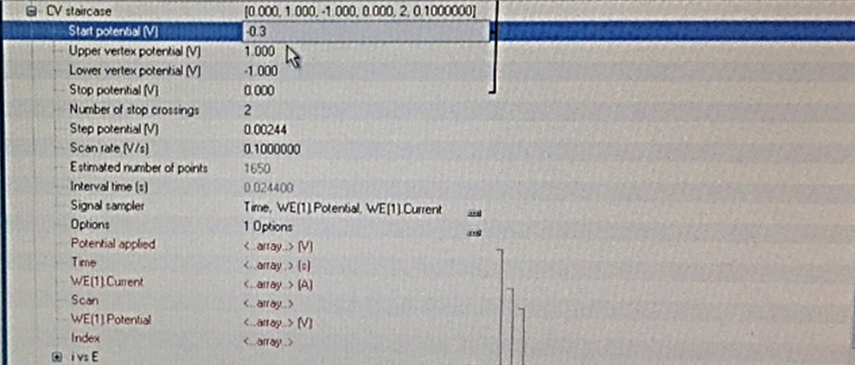

Figure 13: Parameter list for the CV staircase option in the NOVA software.

1. Now, the parameters of Upper vertex potential, Number of stop crossings, and Scan rate, which are in the list of parameters for the CV staircase option, should be modified. **▲**

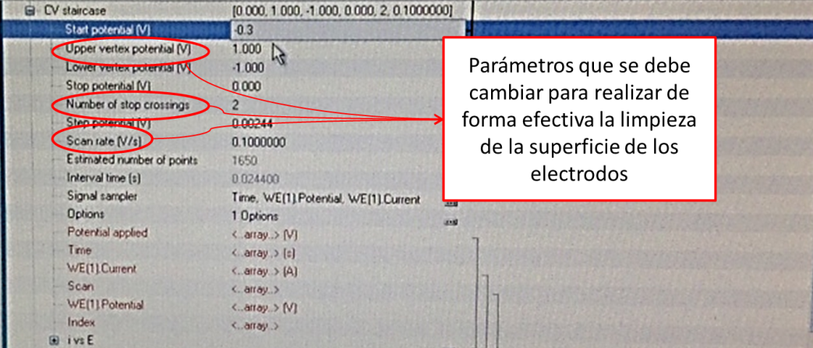

Figure 14: Parameters to be changed for the CV staircase option.

* Upper vertex potential (V) = 1.2
* Number of stop crossings (V) =10
* Scan rate (V/s) =0.1

1. Then, the electrodes to be cleaned are placed inside the diluted sulfuric acid and kept as still and as close to each other as possible. Then, click "start" in the NOVA software to start the cleaning process. **▲**

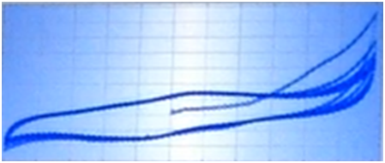

Figure 15: Desired result at the end of the electrode cleaning process.

***Note:*** In this technique, it is known that the surface is clean when each repetition is much more similar to or identical to the previous repetition.

1. When the simulation is finished and it can be seen that each repetition starts to overlap more with the previous one, remove the electrodes and store them.

## WAY TO MEASURE THE OXIDATION AND REDUCTION OF A MOLECULE

### MATERIALS TO USE

* Potentiostat.
* Ferri/Ferrocyanide solution.

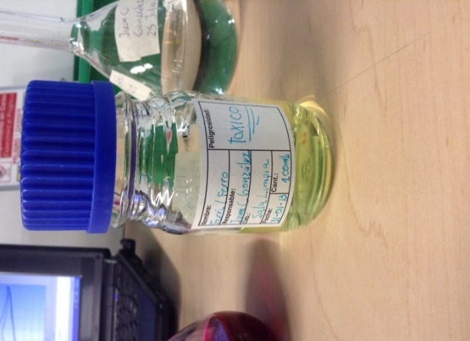

Figure 16: Potassium Ferri/Ferrocyanide Solution.

* Clean copper and gold electrodes.
* USB cable.
* NOVA software.
* Electrode cables and potentiostat clamps.

### PROCEDURE

1. Put the Ferri/Ferrocyanide solution in a beaker.
2. Repeat the steps of the procedure in 3.3.3 Way to clean the surface of an electrode that have the symbol ▲ at the end of the step description.
3. After the previous step, put the copper and gold electrodes in the potentiostat clamps and submerge them in the Ferri/Ferrocyanide solution inside the beaker. The electrodes must be still and as close together as possible until the simulation is finished. After the simulation, the following results can be observed:

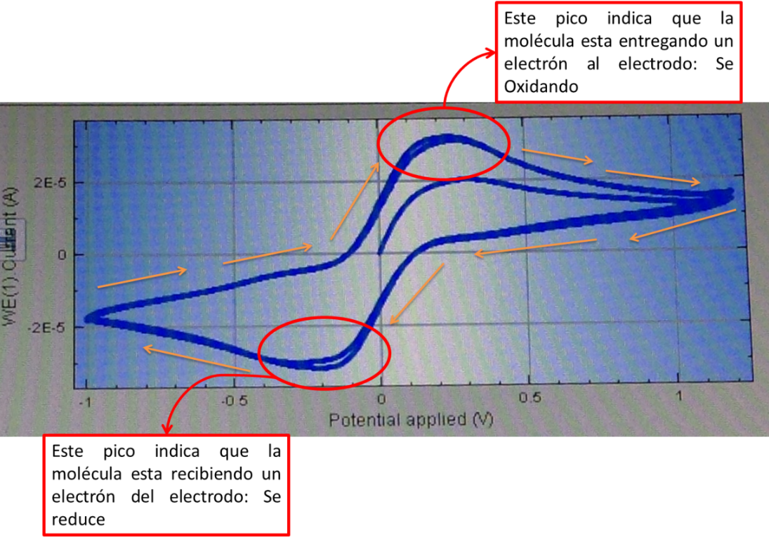

Figure 17: Result of measuring the oxidation and reduction of molecules of the Ferri/Ferrocyanide solute.

1. The Ferri/Ferrocyanide solution is an electrolyte that is basically a reaction that gives an electron. The result of this can be seen in the peaks of image 24, where it can be seen that electrons are being given or received.

# ANNEXES

### HOW TO INSTALL NOVA

Go to the Metrohm autolab website: http://www.ecochemie.nl/

Create an account.

During the account creation process, the serial number of the potentiostat is requested, which is: AUT40851.



Figure 18: Serial number of the potentiostat of Sala Limpia at Universidad de los Andes.

After finishing the account creation, wait a few days while Metrohm autolab validates the device's serial number. They will then send an email saying that all the information is correct, so you can download the NOVA software.

# CHANGE CONTROL

|  |  |  |  |
| --- | --- | --- | --- |
| **CHANGE DESCRIPTION** | **DATE** | **VERSION** | **APPROVED BY** |
|  |  |  |  |